2024 Youth Leadership Summit Application
Applicants must be able to attend the Youth Leadership Summit scheduled for Monday, March 18, 2024
sponsored by: 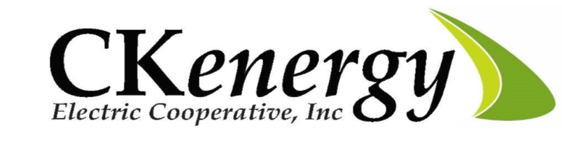
Name: ___________________________________ School: __________________________________
Address: ________________________________ City: ____________________ Zip: _____________
Home Telephone: __________________________ Cell Phone: ______________________________
Email Address: ____________________________________________________________________
Parent/Guardian Names: _____________________________________________________________
Date of Birth: _______________________ High School GPA: _____ Hooded Sweatshirt Size: ____
Please list any school related or extracurricular activities in which you have participated and any special honors you have received. You may attach an additional page if needed.
_________________________________ _______________________________
Applicant’s signature and date Parent/Guardian signature and date

Application Deadline: February 15, 2024
Mail or hand deliver application to:
CKenergy Electric Cooperative, c/o Lisa Willard
P.O. Box 100, Cordell, OK 73632
Email applications to: lwillard@ckenergy.coop
Questions? Please contact
Lisa Willard at 405-656-9114

