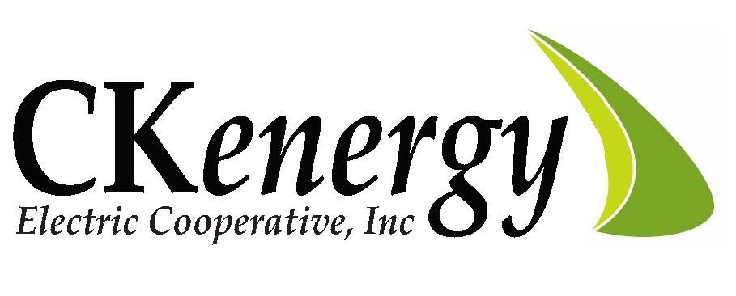
2024 Leadership Summit
Two high school juniors or seniors from CKEC’s service area will receive a $500 scholarship and attend the 2023 Oklahoma Electric Cooperative Leadership Summit at the Oklahoma State Fairgrounds on March 18, 2024.
1. Students must currently be a junior, or senior attending a school in CKEC’s service area. It is not necessary that the student's parents be members of CKenergy Electric Cooperative.

2. Contestants will be required to write a 500 word essay on the topic, “What does it mean to be a Leader?”

3. Essays must be typed and double spaced on only one side of the paper.

4. Attach a completed entry form to your letter.

5. Deadline for all entries is February 15, 2024.

For more information contact:
Lisa Willard 405-656-9114

